CS 461: Senior Software Engineering Project Requirements Document

Prototype a web-based tool for creating and executing task-delineated, collaborative, AI-assisted assignments

Group 28

Team Roles

| Name | ONID | Role |
| --- | --- | --- |
| Oliver Zhou | zhouo | Project Manager |
| Trent Matsumura | matsumut | Developer - Backend |
| Ethan Lu | luet | Developer - AI Integration |
| Collin Kimball | kimbacol | Developer - Web UI |
| Sai Meenakshisundaram | meenkass | Documentation |

# Contents

**Contents 2**

**1. Introduction 3**

1.1 Problem Statement 3

1.2 Purpose and Motivation 3

1.3 Target Audience 3

1.4 Benefits to Users 4

1.5 Market Analysis 4

**2. Project Goals 5**

2.1 Goals, Signals, and Success Metrics Table 5

**3. Project Overview 5**

3.1 Project Scope 5

3.2 Functional Requirements 6

3.3 Non-functional Requirements 6

**4. User Stories and Use Cases 7**

4.1 User Stories 7

4.2 Use Case Diagram 8

**5. Constraints and Considerations 9**

5.1 Constraints 9

5.2 Dependencies 9

5.3 Acquisition Strategy 9

**6. Project Features: Milestones and Timeline 10**

**7. Document Improvements 11**

**8. Individual Write-up 12**

**Appendices 12**

A1. Glossary 12

A2. Revision Requirement 12

A3. Version History 13

**Team Activities 14**

# 1. Introduction

## 1.1 Problem Statement

Current Learning Management Systems (LMS) platforms, such as Canvas, are limited in their ability to effectively support organized, complex, learning experiences, and there has been limited exploration into the productive integration of Large Language Models (LLMs) into the modern education paradigm. Furthermore, students have been incentivized to use AI chatbots as a shortcut tool for completing assignments which has undermined positive learning outcomes. A tool does not exist to address these gaps through enhancing LMS functionality, focusing on areas where these critical features are missing or underdeveloped.

## 1.2 Purpose and Motivation

The motivation behind this project is to improve upon the existing LMS framework, creating a tool that not only manages learning tasks more extensively (i.e. via task-delineation), but also fosters positive associations between AI chatbots and learning outcomes. This project seeks to balance the capabilities of LLMs with an emphasis on educational value, shaping LMS functionality to align with modern academic needs. The ultimate goal is to make course organization easier for professors, and promote the feeling of a “learning journey” for students, providing a substantially improved student experience.

## 1.3 Target Audience

This project is designed to address two key userbases:

* **University Instructors:** This tool will assist university instructors in creating, organizing, and tracking assignments with AI-driven insights that can help monitor student progress and foster better learning outcomes.
* **University Students:** Students who work on individual or group assignments within their professors courses will be provided with AI-assistance offering suggestions for their learning. With clear organization/task-delineation and AI-assistance, students can manage their academic responsibilities with greater ease.

## 1.4 Benefits to Users

1. **Enhanced Task Organization**: The tool enables professors to create, assign, and monitor complex assignments. Professors can organize course assignments effectively under this assignment creation concept, which promotes transparent instructions which are easy for students to follow.
2. **Constructive Use of AI for Learning**: By integrating AI as an educational support tool rather than a shortcut, this tool encourages students to engage more deeply with their work. This tool guides students through the process of thinking through course material productively with the help of AI/LLMs.
3. **Feedback and Improvement Insights**: Report generation can aggregate insights on student submissions, identify their strengths and weaknesses, and suggest areas for improvement. It will benefit users by providing feedback based on completed tasks and interactions, making the facilitation of continuous improvement more streamlined and transparent.

## 1.5 Market Analysis

Canvas is the most prominent LMS in higher education, widely adopted by every big education institution. Canvas offers a range of features for course management, task assignment, grading, and communication between instructors and students. However, Canvas is limited in several regards which opens opportunities for improvement. Some of these limitations are as follows:

* Lack of AI-Assisted Features:
  + Student AI-Assistance: Canvas does not offer AI-assistance to students in a structured and productive manner.
  + AI-Generated Reports: Canvas does not algorithmically provide any reports to instructors in a time-efficient summary.
* Complexity: Canvas has a limited assignment creation function that is unable to delineate tasks into a ‘timeline’ for consecutive assignments. The lack of organization and complexity means instructors are unable to create progressive assignments and tasks are more difficult for students to follow.

# 2. Project Goals

## 2.1 Goals, Signals, and Success Metrics Table

| Goal | Signal | Metric |
| --- | --- | --- |
| Improve task organization for instructors and students | Users can easily create and track assignments with clear task delineation | Survey professors on a likert scale that has 80% or more neutral-positive responses. |
| Facilitate efficient tracking of student progress for instructors | Instructors can easily monitor task completion and student progress across assignments | 80% of instructors report on the survey that student progress tracking is easier or faster. |
| Encourage productive, AI-assisted learning | Adoption of AI recommendations and feedback on assignments | User surveys from students report that 70% of students found that AI helpers in their assignments assisted completion. |
| Finding and keeping track of homework should be easier on the new system | Students actively follow structured learning paths that are easy to keep track of. | Users report that keeping track of assignments broken up into parts was a positive change in the new system exceeds 70% |
| Improve feedback compared to traditional LMS | Students use AI helper bots to refine learning and progress through assignments | Percentage of students who report that metacognitive bot gave them a positive experience with thinking through problems exceeds 70% |

# 3. Project Overview

## 3.1 Project Scope

The scope of this project is flexible, and this section acknowledges the possibility that the scope of the project is negotiable between the “business” and “technical” sides. For now, the scope of this project is to use existing LLM tools to create a web-UI that exports assignment objects into a pre-existing LMS. The web-UI only expands to create complex assignments and integrate AI.

## 3.2 Functional Requirements

**Assignment and Task Creation**: Instructors can create assignments, breaking them down into multiple delineated tasks with their own details, submission items, deadlines, etc., and assign them to students or groups.

**Customizable AI Models**: Instructors can configure AI assistance for specific tasks, tailoring chatbot responses to align with specific learning objectives. They can also designate when and where to implement AI models for their assignments.

**Metacognitive Bot:** A bot that is able to understand the context of course material and specifically output prompts to students which promote metacognition and assist students with summarizable information.

**Progress Tracking and Reporting**: Instructors can track progress on tasks and assignments through traditional means (ex. grading tools), along with generated reports from AI to help instructors understand their students’ performance.

**Exporting Assignment Objects**: Instructors can generate exportable and pastable versions of their delineated assignments to import into LMS such as Canvas.

## 3.3 Non-functional Requirements

**User-Friendly:** The tool should be easy to understand and use – no more complex or difficult to understand than Canvas, per say.

**Safety and Security:** It is important that students are protected in a safe learning environment, which means that this tool should make sure large security vulnerabilities are taken care of, as data privacy and security are frequent concerns in the AI/LLM space.

**Availability:** The tool’s web-UI should be durable and sustainable – meaning it remains functioning and available at all times to match Canvas.

**Flexibility:** The tool should be maintained in a manner that is flexible and easy to reconfigure, because project requirements may change – the specific needs of other requirements in the project may need to be reconsidered.

# 4. User Stories and Use Cases

## 4.1 User Stories

| User Role | User Story | Criteria |
| --- | --- | --- |
| University Instructor | As a university instructor, I want to be able to build and execute more complex assignments which assign multiple tasks, so that I can better organize my material. | - Instructors can create assignments that consist of multiple tasks, with their own title, description, deadline, and submission items.  - Instructors can organize tasks in a structured sequence or hierarchy to guide students through complex assignments. |
| University Instructor | As a university instructor, I want to be able to aggregate data about my students' performance, so that I can quickly understand how they are performing and interacting with my course. | - Instructors can view aggregated data for each assignment, such as places of AI-assistance use, and AI-generated summaries of key strengths and weaknesses.  - Instructors can efficiently view student progress summaries to assess their assignments and help continuous learning. |
| University Instructor | As a university instructor, I want to designate when AI is appropriate and tailor chatbots to assist in those instances so that I can productively utilize AI in my classroom. | - Instructors can enable or disable AI assistance for specific assignments or tasks within the tool.  - Instructors can customize AI responses by adding context from course material and configure the helper bot’s methods. |
| Student | As a student, I want to be assisted through my learning journey, and receive help from an AI chatbot more productively, so that I can have a guided learning experience that improves my learning. | - Students can ask questions about tasks and receive relevant, context-sensitive feedback from the AI chatbot.  - AI feedback and suggestions are actionable, allowing students to improve their work based on the guidance provided. |
| Student | As a student, I want to easily understand the instructions of a complex assignment assigned to me, so that I can better follow along with material and straighten my learning. | - Each assignment provides a clear breakdown of tasks, including descriptions, goals, and instructions for each step.  - Guided learning is appropriately provided to students to help them through complex setups for assignments. |

## 4.2 Use Case Diagram

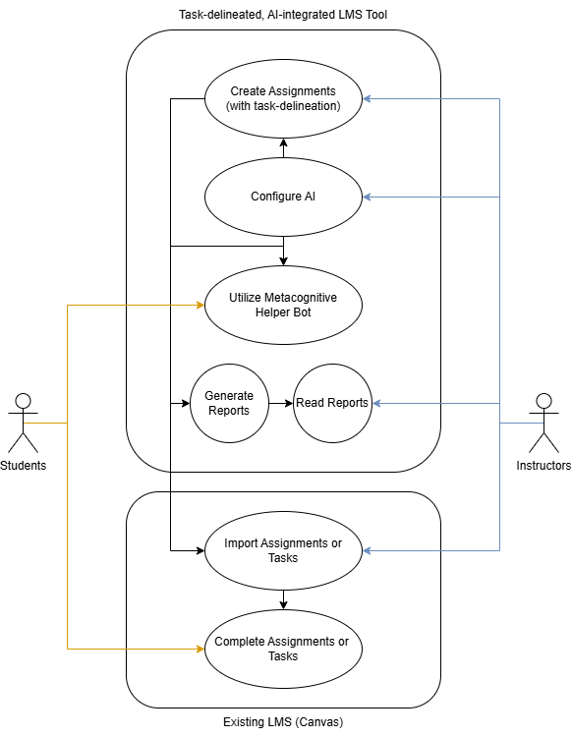

Figure 4.2.1 – Use Case Diagram for Students and Instructors

# 5. Constraints and Considerations

## 5.1 Constraints

* Time: The project must be completed by the end of the Spring 2025 term.
* Creation of our own AI-model is unrealistic – we must use a pre-existing model to integrate.
* The scope of the project does not designate that Canvas can be fully-replaced.
* LLM Integration limitations: The selection of LLMs we have access to have concerns such as API limits, and security compromises. These need to be considered when using third-party AI tools.
* This tool cannot impede on the core functionality of Canvas or other LMS.
* The product must follow guidelines provided by the Capstone course, specifically for the “New Product or Game” category.

## 5.2 Dependencies

* Canvas: The project cannot in its current scope fully replace the pre-existing LMS ecosystem. Because of this, this project still depends on Canvas to serve the assignments to the students. This tool will instead serve to create organized assignment objects and integrate AI tools to assist with the class management process.
* Existing LLM Tools: This dependency is not decided because the actual implementation of AI into the project has not been settled. However, new tools cannot be developed for this tool and therefore AI features rely on an existing tool to utilize. The tool will make use of these tools easier for end users.
* Project Mentor Needs: Design requirements are given to the technical team by stakeholders, so needs are determined and catered to the desires of our project partner.

## 5.3 Acquisition Strategy

To promote adoption of the tool, project demonstrations via the developed prototype will prove the benefits of this tool. As a new product, key features need to be center focus, which means an emphasis on showing off organization features and AI is necessary.

# 6. Project Features: Milestones and Timeline

| Feature/Milestone | Description | Concurrency Period/Timeline | | Dependencies |
| --- | --- | --- | --- | --- |
| Fall Demo | The Fall demo will be a short “prototype-prototype” for the sake of the presentation. | Week 7–8, Fall | |  |
| Core Interface | The core interface of the website contains the basic user interface that Canvas provides. | Week 0 | |  |
| Assignment Creation (CREATOR Tool) | This feature enables instructors to build an assignment with standard parameters, emulating pre-existing LMS. | Week 0 | | Interface |
| Task-Delineation | This is the second part of the creation tool. This feature enhances the basic assignment creation tool to become more robust. | Week 1–3, Winter | | Assignment Creation |
| Assignment Objects | This feature is what allows the project to integrate into the LMS ecosystem that is already established in our institutions. It will export assignments built in the tool to be easily pasted into Canvas. | Week 1–3, Winter | | Assignment Creation |
| AI Connectivity (Part 1 for Configuration) | Implement a model into the website that is functional and gives responses | Week 1-2, Winter | | Core Interface |
| LLM Configuration (**HARD**)  (CONFIGURATOR Tool) | This feature can easily configure a pre-existing LLM model with options that change depending on the use case of each chatbot. | Week 2–4, Winter | | Core (Teacher) Interface |
| Assignment Creation Prototype Testing | Prototyping the first several milestones for website functionality. This can be done with the project partner | Week 4–5, Winter | | Winter Milestones 1–6 |
| Instructor Dashboard for Submissions | This dashboard allows the instructor to interact with submissions and students. | Week 5, Winter | | Assignment Creation |
| Demonstrate Dashboard | Demonstrate the instructor dashboard | Week 6, Winter | | Dashboard |
| Generating Submission Reports (**HARD**) | This allows the AI configuration to generate reports about student submissions and performance for the instructor. | Week 6–9 | | Dashboard |
| Student Helper Bot (**HARD**) | This standalone bot is designed for the purpose of helping promote metacognition to students. It understands the context of the assignment and guides students with prompts and advice which can be utilized by professors. | Week 5–9, Winter | | AI/LLM Implementati-ons |
| Stretch Goals | Stretch Goals are the features in the project which the implementation of are not decided on yet fully. These were features that were discussed but were low-priority or not required. | Remaining Time if FEATURE milestones are completed early. | |  |
| Alpha Testing the Completed Product | We test the final product with our mentor for completed features | Week 10, Winter | | All FEATURE milestones |
| Beta Testing | Methodology of the testing has not been decided on yet. This will be described later with the project mentor. Spring testing with real users (possibly?) | Week 1, Spring | | Alpha Testing |

# 7. Document Improvements

This section contains a list of some improvements to take note of when revisiting the document in the future:

* Gain additional feedback from project mentors as project needs change or develop down the line.
* Expand on diagrams.
* Fix messy wording and dial in more specifically on vague explanations (if needed).

# 8. Individual Write-up

I want to focus on developing the instructor dashboard and reporting features, as they are central to improving students' learning experience and providing valuable insights into assignment outcomes and overall class performance. This feature excites me because it enables instructors to visualize student progress and leverage AI-generated feedback to better understand both individual and class-wide strengths and areas for improvement. Additionally, I’m interested in designing a user-friendly interface allowing instructors to easily configure chatbots, set specific AI-assistance parameters, and create task delineated assignments.

# Appendices

## A1. Glossary

**AI Chatbot:** An artificial intelligence (AI) application that responds naturally to user queries.

**Artificial Intelligence (AI):** A branch of computer science set on enabling computers to perform complex tasks and understand/analyze data by perceiving their environment.

**Large Language Model (LLM):** An artificial intelligence (AI) model, typically built using neural networks, designed to understand and generate human language.

**Learning Management System (LMS):** A software platform designed to manage class content and student performance.

**Metacognition**: The process of being aware of and understanding one's own thought processes.

**Task-Delineation:** Describes a system that breaks down a larger project into smaller, defined tasks.

## A2. Revision Requirement

This assignment requires that the document is reviewed by the project mentor. This appendix and the version history is an acknowledgement that an email exchange with the project mentor was conducted and revisions were made according to the feedback.

## A3. Version History

v1.0.0 (November 3rd, 2024) – Initial Draft.

* Requirements Introduction
* Project Goals
* User Stories
* Constraints
* Milestones and Timeline
* Activities

v1.1.0 (November 10th, 2024) – First submission for Canvas.

* Document was reworked from project mentor guidance and feedback:
  + Goals, and Metrics
  + Milestones and Timelines
  + Project Focus

# Team Activities

All team activities were done individually for this document. Our activities were conducted separately, since a meet was not possible under schedule this week. We compiled submissions and worked on requirements according to suggestions we made separately. All activities are pasted into the bottom of this document below:

## 1. Oliver Zhou – Individual Activities

### Creative Activity – C-K Theory

1. Concept Exploration (C→C): Start with a broad problem or concept in your project. List unconventional, creative ideas without worrying about feasibility.

One of the broad concepts of this project is the requirement of implementing some kind of productive application of machine learning models for the purpose of improving mental fitness. There are a variety of envisioned implementations of this concept, one of them being summarizing and aggregating class submissions together for comprehensive and concise reports for teachers to understand the strengths and weaknesses of their students. Another one is creating a helper AI that talks to students and understands the context of class material to focus on.

1. Knowledge Expansion (C→K, K→K, K→C): Research and identify new knowledge or technical resources that could support or challenge your concepts.

There are a variety of AI models that already exist which can be implemented into our project. GPT-4 from OpenAI for ChatGPT is the most popular product of all. It responds to almost any prompt, so it may be an interesting avenue to try and get this model to focus in on an educational setting. However, it may be a little too general and easy to trick for our purposes. There are also some products like NotebookLM which are based on Google’s Gemini model which shows that it's possible to have tools that focus on specific tasks.

1. Intersection: Combine the new concepts with existing knowledge to propose innovative solutions.

I believe our solution is not to necessarily create our own tool for AI implementation. Rather we should focus on using one of the pre-existing AI models out there that are robust enough to be used for our purposes. The most powerful model for this purpose as I understand would be some form of OpenAI’s GPT-4, but perhaps the AI expert in the team could find the best tool for the job. This is something that will prompt a discussion I will have with them.

### Requirements Activity – User Story Mapping

My contribution to the document will be through user stories and use case diagrams. I contractured user stories which we implemented into the requirements document here: 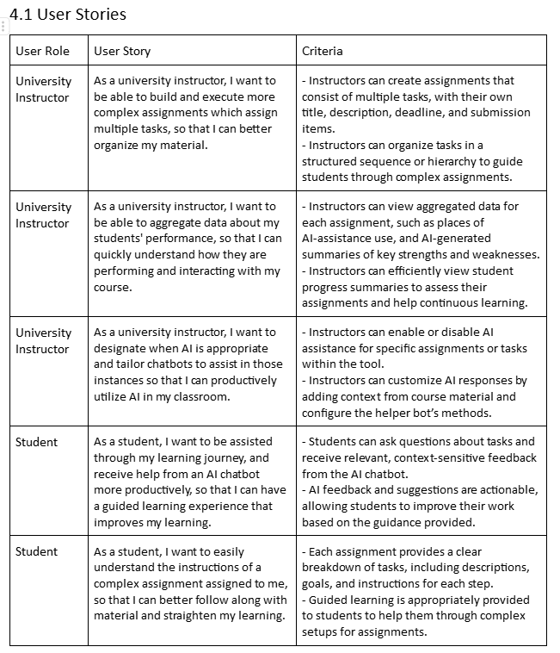

I wrote these for both of our decided target audience and tried to cover different functions or features that they want based on the problem presented in the problem statement.

### Planning Activity – Dependency Mapping or Critical Path Analysis

Map task dependencies and identify the critical path to ensure efficient project scheduling and resource management.

1. List Tasks: Break down the project into individual tasks or activities.

Tasks:

* Assignment Creation
* Task-Delineation
* Assignment Objects
* LLM Configuration
* Student Helper Bot
* Submission Analysis
* Core Interface
  + Student and teacher portions

1. Identify Dependencies: Determine which tasks rely on the completion of others before they can start.

Everything requires at the least the core interface to get started and begin testing. After that, the standard LMS functions that are in traditional applications need to be created as well. Those are the basis to work off for the rest of the project. After that, various features such as integrating AI for whichever tasks and task-delineation are dependent on that, but can mostly be done concurrently with each other. AI tasks require an AI configuration, and organization features require assignment creation, objects, and teacher interface features and student interface features.

1. Create a Critical Path Diagram: Map out the sequence of dependent tasks and identify the longest path (critical path) that determines the project timeline.

The likely critical path is the Helper bot.

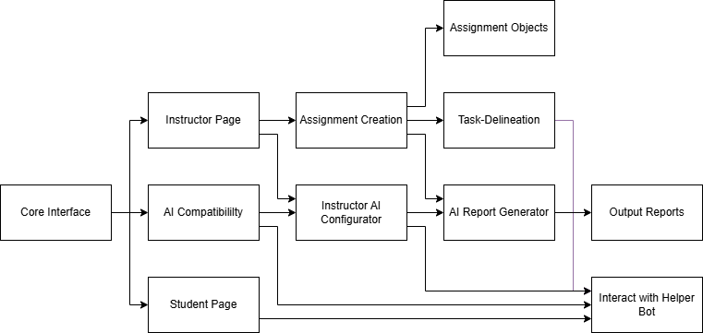

1. Analyze and Adjust: Identify potential bottlenecks and adjust timelines accordingly.

Bottlenecks could happen from either too many dependencies, or raw difficulty from the task. I suspect that AI integration will be harder as the critical path even though the assignment functions such as the output records have more dependencies. I suspect that it will be more difficult to properly implement each feature like the configurator and implementing a bot that can focus on the assignment context.

## 2. Sai Anand – Individual Activities:

### Creative Activity: Literature Review

The literature surrounding AI-assisted educational platforms highlights both the potential and challenges of integrating artificial intelligence into learning environments, particularly in the context of assignment creation and management. AI in education has been a focal point of recent studies, with research underscoring its ability to automate routine tasks, provide personalized learning experiences, and enhance real-time feedback. For example, Chen et al. (2021) discuss the ways AI-driven tools can alleviate instructors' workloads by taking over time-consuming tasks like grading and feedback generation, allowing educators to dedicate more time to teaching itself. This resonates with AI Academic Toolkit’s goal of reducing the administrative burden on teachers, freeing them to focus on more meaningful interactions with students. Additionally, literature on AI-enabled personalized learning, such as Wang et al. (2020), illustrates how AI can adapt assignments based on students' unique learning paces and styles, which not only fosters greater engagement but also improves knowledge retention. This notion of personalization directly aligns with the objectives of AI Learning Management System, which aims to offer tailored assignments that respond to each student's needs and performance level.

Research on automated content generation further emphasizes AI's capacity to bridge gaps in educational resources by creating tailored content, such as quizzes and exercises, that meet learning objectives effectively. Zhang et al. (2022) note that content-generating AI tools can ensure consistency and adaptability in instructional materials, which is valuable in rapidly changing curriculums or for varied student abilities. AI-Powered Academic Toolkitwill leverage this capability to streamline assignment creation for educators, minimizing the manual input required while allowing customization to suit different student profiles. Additionally, recent studies stress the importance of assignment management and analytics, highlighting how data-driven insights can be instrumental in identifying struggling students early on. For instance, Johnson and Lee (2023) argue that real-time analytics empower instructors to take timely action, providing support where needed. By integrating similar analytical tools, AI-Powered Academic Toolkitwill help educators track student progress and adjust assignments as necessary, promoting a proactive and responsive teaching approach. Overall, the existing literature provides a robust foundation for developing AI-Powered Academic Toolkitand offers valuable insights into designing a platform that combines automation, personalization, and analytics to enhance educational outcomes.

### Requirements Activity: User’s Emotional Objectives

While functional goals, such as creating and managing assignments, are critical for AI Learning Management System, it's equally important to consider the emotional objectives that will drive user satisfaction. The primary audience for this platform includes educators, who may have emotional needs related to productivity, professional growth, and ease of use. Key emotional objectives for AI-Powered Academic Toolkitinclude:

1. **Sense of Accomplishment**: Educators want to feel they’re positively impacting students' learning outcomes. By providing AI tools that simplify assignment creation and offer real-time feedback, the AI-Powered Academic Toolkit can enhance teachers' sense of accomplishment and mastery of new teaching methods.
2. **Reducing Workload Stress**: Educators often face time constraints due to heavy workloads. By automating routine tasks like grading and generating assignments, AI-Powered Academic Toolkitcan alleviate some of this pressure, promoting a sense of relief and reduced stress.
3. **Professional Growth**: As AI continues to reshape the educational landscape, many instructors are eager to embrace technology that can improve their teaching strategies. AI-Powered Academic Toolkitoffers a platform for educators to experiment with AI-driven assignments, making them feel tech-savvy and adaptable in their professional roles.
4. **Student Connection**: Educators value fostering a close connection with students and may worry about losing this with AI integration. AI-Powered Academic Toolkitwill allow teachers to customize AI interactions to maintain a personal touch, reassuring them that the platform complements, rather than replaces, their engagement with students.

### 3) Planning Activity: Risk Management Plan

The risk management plan outlines potential project risks, categorizes them by impact and likelihood, and describes mitigation strategies.

1. **Technical Risks**:
   * **Risk**: Limited technical knowledge in AI or integration challenges with the selected AI technologies.
   * **Impact**: High
   * **Likelihood**: Moderate
   * **Mitigation Strategy**: Team members will undergo relevant training, and we’ll consult technical mentors or AI experts as needed.
2. **User Adoption Risks**:
   * **Risk**: Educators may resist using the platform due to unfamiliarity with AI tools or skepticism about their efficacy.
   * **Impact**: Moderate
   * **Likelihood**: High
   * **Mitigation Strategy**: Conduct user testing with early adopters and incorporate feedback to make the tool more intuitive. We will also create tutorials and support resources to assist users in adopting AI Learning Management System.
3. **Data Privacy Risks**:
   * **Risk**: Protecting sensitive student data in compliance with privacy regulations.
   * **Impact**: High
   * **Likelihood**: Moderate
   * **Mitigation Strategy**: We will implement robust encryption and user access controls to ensure data security and comply with privacy laws (e.g., FERPA).
4. **Scope Creep**:
   * **Risk**: Uncontrolled expansion of project features beyond the initial scope.
   * **Impact**: High
   * **Likelihood**: Moderate
   * **Mitigation Strategy**: Establish clear project milestones and regularly review the scope with stakeholders to avoid adding unnecessary features.
5. **Integration Challenges**:
   * **Risk**: Compatibility issues with existing school systems or LMS platforms.
   * **Impact**: Moderate
   * **Likelihood**: Moderate
   * **Mitigation Strategy**: Prioritize compatibility testing and create a flexible API structure that can adapt to different LMS environments.

## 3. Trent Matsumura

### Creative Activity

#### Apply the C-K Theory:

1. Concept Exploration (C→C): Start with a broad problem or concept in your project. List unconventional, creative ideas without worrying about feasibility.
2. Knowledge Expansion (C→K, K→K, K→C): Research and identify new knowledge or technical resources that could support or challenge your concepts.
3. Intersection: Combine the new concepts with existing knowledge to propose innovative solutions.

1. AI chatbot, Report Generation, Assignment Creation.

2. For AI chatbots there are already tons of pre-existing models that we could use and implement, ChatGPT, Microsoft CoPilot, Google Gemini, etc. For report and assignment generation, these are also linked with AI implementation. With a bit of searching, we can use resources such as tools like piktochart or other free lance AI generation tools.

3. We can create our AI models by using and utilizing pre-existing models that can greatly improve and speedup our processes for using AI.

### Requirement Activity

#### User’s Emotional Objectives:

* What emotions is the user seeking when using the software?
* How does the software impact their relationships or self-perception?

Submit an analysis of your project from the perspective of the user's emotional objectives, explain which user segment or audience you are targeting.

The project’s audience will be targeted to two different groups, instructors and students. These two groups have very different feelings about AI based assignments and homework in general. For the instructor side, they want students to properly do assignments and gain knowledge during the process of solving problems. AI does not generally assist the process and usually is seen as a shortcut in the world of education. Our project aims to ease this worry by incorporating AI with learning so that AI may be used truly as a tool instead of a cheat. For students the emotional aspect would be utilizing AI to make work as easy as possible so that homework doesn’t stress them out as much. However we wish to still keep AI so that homework moves smoothly without stress inducing assignments while also encouraging a proper mindset when interacting with AI. This would allow students to have an easier time doing homework itself, because they may use AI, without completely omitting the learning aspect.

### Planning Activity

#### Definition of Done:

1. List Completion Criteria: Define specific conditions that must be met for each task or feature to be marked as “done” (e.g., all tests passed, documentation updated, code reviewed).

Since the project is based on completing a project and tool, the completion criteria is based on how functional the final product is. The criteria for the final tool would be a working functional prototype application that can successfully give a user an AI generated delineated assignment. This assignment should have a chatbot assisting the user and allow a second user to see the assignment and receive feedback via AI while being able to manually input their feedback. In summary,

* All AI portions of the project are working and able to produce desired outputs.
* Code produces a tool that can be run off of a sharable link.
* Code has been reviewed and thoroughly tested via test cases.

1. Include Quality Standards: Ensure the criteria cover quality aspects like performance benchmarks, usability, or security.

Main criteria to cover is usability and performance. The app should be easy to use while meeting the heuristics and provide a smooth experience for the user without any hiccups. As for security, it's not that important in this project as the main focus doesn’t involve any use of personal information or vital info that would be harmful if leaked to the user. In summary,

* Bench marks should be that the tool runs smoothly with no faults. No crashes and run time should not be exceptionally long.
* Usability, the UI and layout should look very neat and concise, with double checking from all members.

1. Team Agreement: Discuss the definition with your team and ensure everyone agrees.

Our team has agreed on the definition of what done looks like in our eyes.

## 4. Collin Kimball Activities

### Apply the C-K Theory

1. Concepts:
   1. Task delineated Assignment Builder
   2. Instructor performance dashboard
   3. User friendly interface
2. There are component libraries and frameworks that can be used to efficiently develop these concepts for the web UI.
   1. Component libraries such as ShadCN have a variety of accessible and customizable components that can be used to quickly build out the assignment builder and performance dashboards while keeping a user-friendly interface.
   2. We can utilize frontend frameworks such as React to create reusable components to reduce development time.
3. By leveraging component libraries like ShadCN and frontend frameworks like React, we can efficiently develop a user-friendly tool that features a task-delineated assignment builder and instructor performance dashboard, making complex assignments clear for students and providing actionable insights for instructors.

### Domain Model

Task delineated assignment builder

* Entities: Instructor, Course, Assignment, Task, PerformanceReport
* Relationships:
  + Instructors have multiple courses
  + Courses have multiple assignments
  + Assignments have multiple tasks
  + Assignments have a performance report

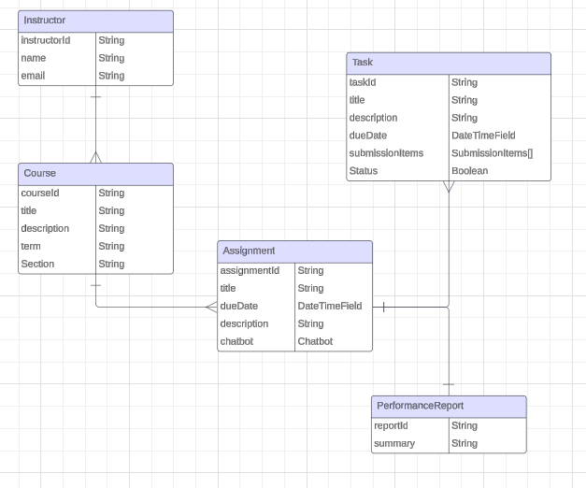

### Weekly Work Intensity

| **Week** | **Predicted Effort** | **Actual Effort** | **Other Commitments** |
| --- | --- | --- | --- |
| 0 | Low | Low | Interviews |
| 1 | Low | Low | Interviews |
| 2 | Medium | Low | CS450 Project |
| 3 | Medium | Low | Interviews, CS450 Project |
| 4 | Low | Low | CS450 Project |
| 5 | High | Low | CS450 Midterm |
| 6 | Low | Medium | Interviews, CS450 Project |
| 7 | Medium |  | CS450 Project |
| 8 | Medium |  |  |
| 9 | N/A |  | CS450 Project |
| 10 | Low |  | CS372, CS450 Final |

During week 6, I put in a medium amount of effort working on the requirements document. I plan to continue having medium/high effort throughout the following weeks as well.

## 5. Ethan Lu – Individual Activities

### Creative Activity

#### Apply the SCAMPER method:

* Substitute
* Combine
* Modify/Magnify/Minify
* Put to another use
* Eliminate
* Rearrange

Utilizing the SCAMPER method to creatively enhance the AI-assistance of our assignment web tool.

Substitute:   
Rather than using and training our own AI chatbot, we can substitute building one from scratch with a preexisting one, such as implementing freelance artificial intelligence such as ChatGPT or Canva into our web tool. Alternatively, we can substitute building one from scratch by using these models as examples to create our own models. This can both simultaneously increase the quality of our product by using more refined tools and reduce the workload.

Combine:  
We can potentially combine our student AI-assistant with our autograder, or the data they are trained on in the case of a fully AI grader. In this way, we can ensure our trained AI will not give incorrect feedback and aid to students ensuring they trust our model more than other online models.

Modify/Magnify/Minify:  
We want to magnify the emphasis of AI-assisted assignments. To do this, we can modify our web tool to allow the option for teachers to only allow progress in parts of assignments after interacting with our AI assistant. In this way, we can ensure students are properly using the provided AI tools.

Put to another use:  
To help students understand and learn through AI-assisted assignments, we can reutilize an AI grader. Ideally, our web tool will contain an auto-grader for teachers to use. We can put this aspect to another use and allow students to run it like a check-script to give immediate feedback on which parts of an assignment are failing to meet standards without giving them correct answers. They can use this AI feedback with the AI assistance.

Eliminate:  
As our goal is to ensure students can ethically use AI to assist in their learning, we could eliminate standard plagiarism flagging tools. Instead, our implemented AI should instead guide students through recommending verified articles and helping them to understand necessary formatting for citation.

Rearrange:  
To emphasize ethically using AI to assist in learning, we should rearrange assignments to have multiple stages through which students must progress, having them use an AI assistant through each step to ensure proper education at each point. Rather than linear assignments submitted as one whole, they must be rearranged to be formatted in parts where students can access AI assisted learning tools at each part.

### Requirement Activity

#### SWOT Analysis

* Strengths: Identify the internal strengths of your project (e.g., team skills, resources).
* Weaknesses: Determine internal weaknesses (e.g., limitations in knowledge, budget).
* Opportunities: Explore external opportunities that could benefit your project (e.g., new technologies, partnerships).
* Threats: Identify external risks or challenges (e.g., competitors, regulatory issues).

Strengths: The project has multiple internal strengths. All team members have adequate skills in computer science and web development, and as students have a clear understanding of the weaknesses of a standard assignment web tools such as Canvas. Furthermore, as students, each team member has a strong understanding of how and when students choose to use AI to aid them in assignments, and for what purposes they employ the use of them rather than utilizing other resources.

Weaknesses: An internal weakness our team will struggle with is a lack of resources and experience in training language models. The extent to which we will build and train our own AI assistant is still subject to change, but as we lack a large pool of data to train AI models, it may be difficult to accomplish. Our prototype AI assistant will likely only have very moderate capabilities, and training it for future versions may prove to be very difficult.

Opportunities: Some external opportunities we can take advantage of are other online large language models that can be found online. Examples include ChatGPT and Microsoft Copilot, and by studying and researching these tools we could benefit. Another way we may benefit from these is utilizing open freelance language models which can potentially be trained on our own data, as partnering with such tools would drastically improve quality and reduce workload.

Threats: One threat to our project is resistance to change. WIthout significant reason to change to a new platform, most people will choose to stick to a software they are familiar with. Because of this, we need to make our web tool either a significant boost to current software such as Canvas to encourage swapping, or potentially external plugins that could be utilized by a resource such as Canvas. Otherwise, current teachers will have little incentive to change to using our web tool, and students will not benefit from it.

### Planning Activity

#### Weekly Work Intensity:

| Week | Expected | Actual | Notes |
| --- | --- | --- | --- |
| 1 | Low | Low |  |
| 2 | Low | Low | Operating Systems 2 Lab Week |
| 3 | Low | Low |  |
| 4 | Medium | Low | Operating Systems 2 Lab Week |
| 5 | Medium | Low |  |
| 6 | High | Low |  |
| 7 | Low | N/A | Operating Systems 2 Lab Week |
| 8 | High | N/A |  |
| 9 | High | N/A |  |
| 10 | Low | N/A | Dead Week |
| F | Low | N/A | Finals Week |

Week 6 Reflection:

While I did expect my actual effort to be low in the beginning weeks, I hoped to pick up my work ethic at about week 4 to begin work on the team project. However, I have repeatedly put off beginning work on it and have given only low effort attempts as of week 6 so far. I need to better manage my time by completing more of my work beforehand, specifically for some of the other online courses I am taking this term, so that I can more rigidly focus on the capstone project. I will attempt to do this by setting weekly alarms for myself so that I am always at least 3 days ahead of assignments for other classes (exception of unposted assignments).

eod.